**Task#3:**

**Create a lambda function to send an email notification to your email id of your AWS account, as soon as you delete a file from an S3 bucket, mentioning the file name which is deleted.**

Here we’ll be using 4 services

1.AWS Lambda

2. IAM role

3. S3 bucket

4. SES – for sending email notification

The Flow will be like

Any object deleted or created in S3 bucket then it will trigger an event in form of lambda function , so the lambda will be triggered and using lambda function an email notification will be sent to the user.

We’ll start by creating an IAM role for the lambda function

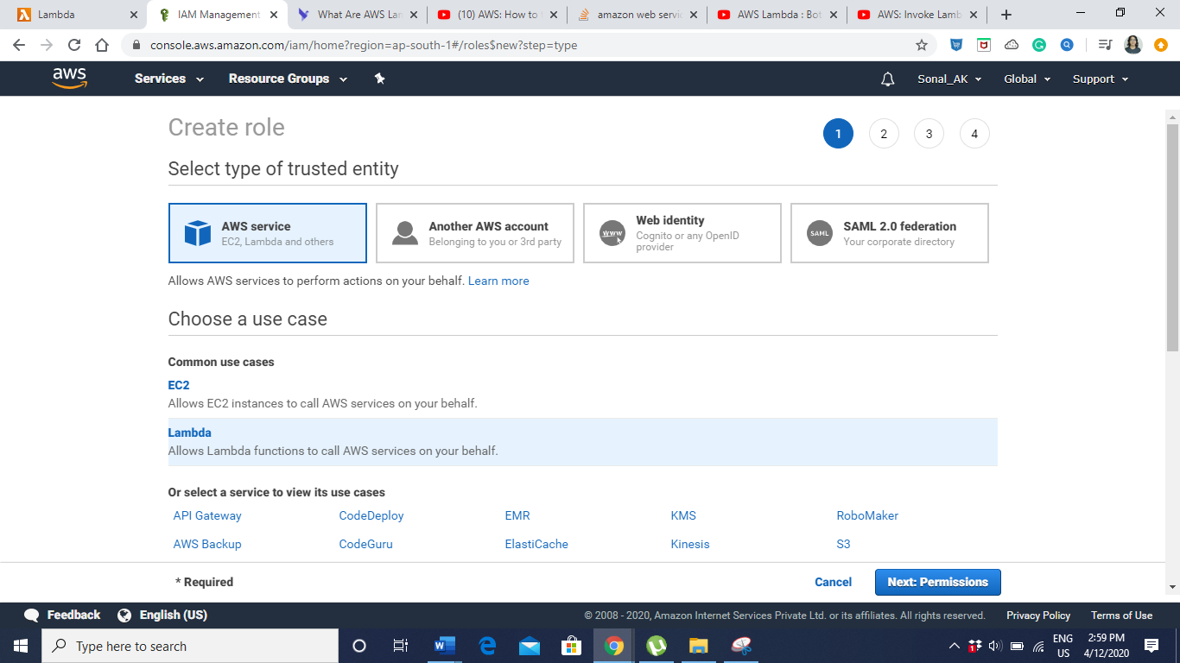

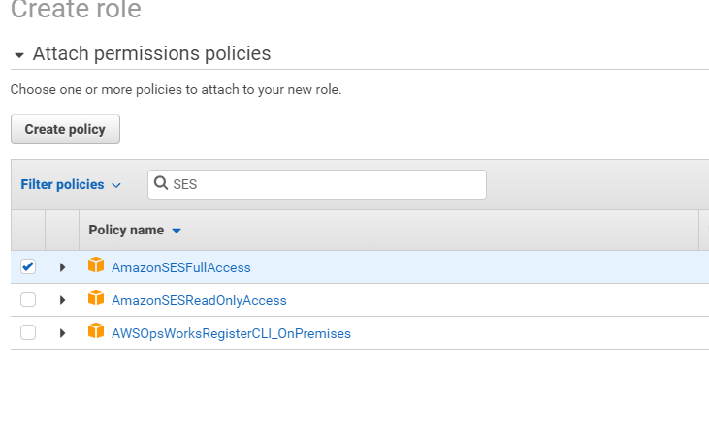

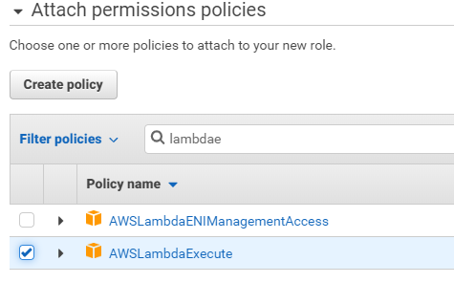



Now lets go to S3 bucket

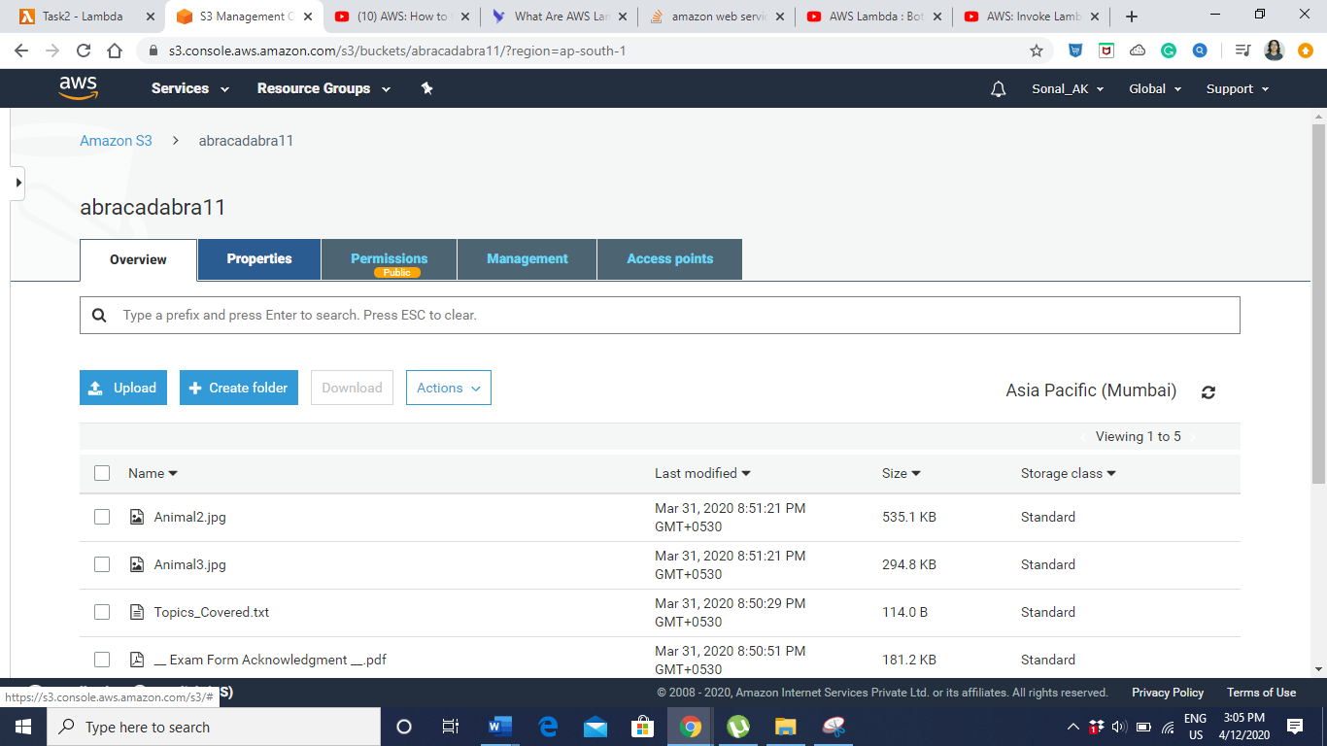

Go to Properties panel

We’ll go to events and click on add notification

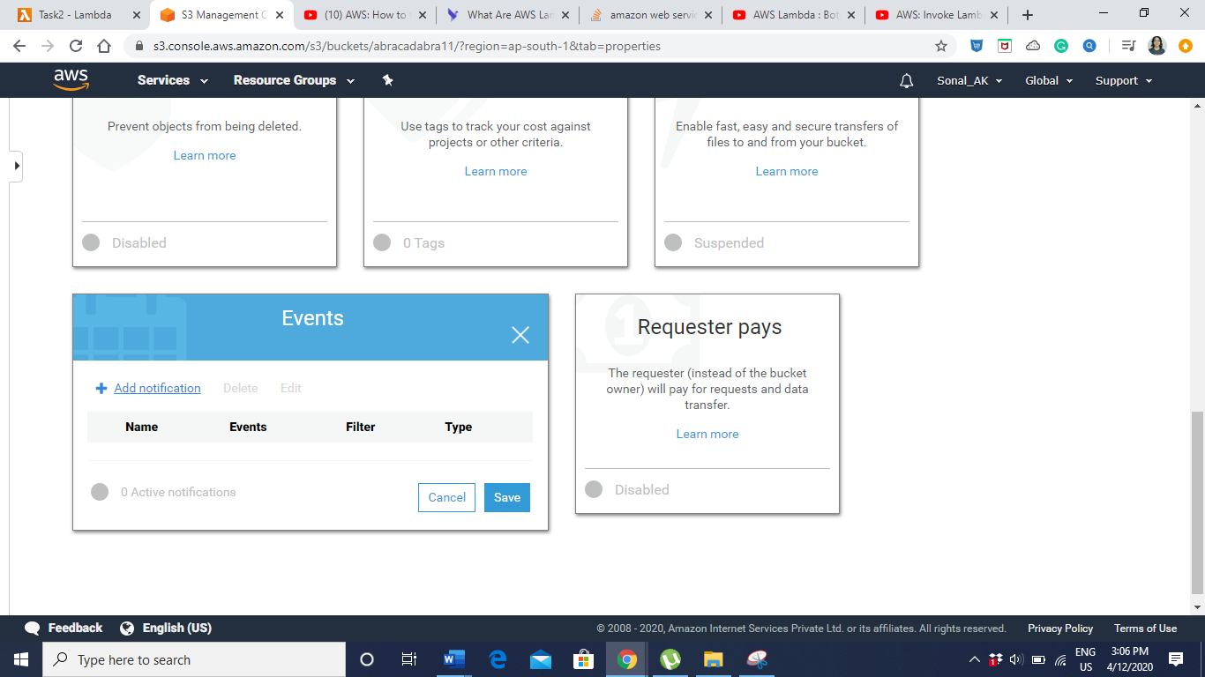

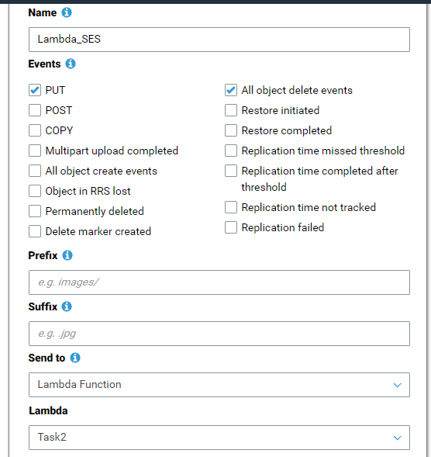

If you want to trigger this notification for a particular file like .jpg,png we use suffix and for a change in directory we use prefix.

After this we’ll create the Lambda Function.

Create & verify the email id’s in SES before running the lambda code.